**1.INTRODUCTION**

**1.INTRODUCTION**

Internet of Things (IoT) is the networking of physical objects that contain electronics embedded with their architecture in order to communicate and sense interactions amongst each other or with respect to the external environment. Nowadays everything is becoming smart. Agriculture is the major constituent in India. So why can't we make agriculture smart? This is where the idea for taking up this project has started. This led a way to the encapsulation of Smart Irrigation and detection of suitable crops that can be grown.

**1.1 INTRODUCTION**

The **Smart Irrigation System** has a wide scope to automate the complete irrigation system. Here we are building an **IoT-based Irrigation System** using the ESP8266 Node MCU Module and Resistive soil moisture Sensor. It will not only automatically irrigate the water based on the moisture level in the soil but also send the data to Blynk Application to keep track of the land condition. The System will consist of a water pump which will be used to water on the land depending upon the land's soil moisture condition.

We are making this prototype for controlling our farm activity independently from any end of the world. We can monitor real time data on the screen of our mobile, plus we can understand environmental sensors from this which is used to monitor the motor pump. With the help of IOT, we can control our garden/ farm appliances, so these are some important things.

Following are the pros of this system:

* Control the irrigation system in an automated fashion.
* Should work Autonomously by sensing soil moisture levels.
* Should be Inexpensive to build, but must be reliable.
* Should be operated remotely.
* Should be beneficial for farmers as the crops can be grown are known beforehand.

It will perform the following tasks:

1. It has one mode, that is the self-mode
2. In manual mode we can monitor the motor pump based on the amount of water approximately measured. In this mode, we can control the appliance depending upon the current situation of moisture level manually.
3. But in a self -mode the system will become independent from its owner's operation, it can perform its work on its own, simply it will handle itself Smartly based on the current situation.
4. It also mentions the suitable crops that can be grown under the measured moisture content which in turn helps the farmer to ensure the type of crop can be grown.
5. Thus, this project is a two - way project where we can know the suitable crops that can be grown in the soil before irrigation and the irrigation can be monitored smartly through an android application during irrigation.

The details for displaying the suitable crops can be brought from the dataset having the names of the crops and the amount of moisture that is necessary to grow. In the code the conditional statements are written based on the moisture content measured to display their names. The pump can be operated according to the moisture content necessary for the healthy growth of the crop through the Blynk application, an android application.

The IoT is an emerging technology in industry 4.0. This is an embedded technology where everything is connected to the internet and is operated through a device. Some well-known applications are Smart Watch, Smart Agriculture, Smart City and many more. From the surveys it is also estimated that there will be more smart devices than population as each individual carries more than one smart device by 2030. So, there is also a need for an application that helps in the agriculture sector for meeting the needs of gradual increase in population all over the world.

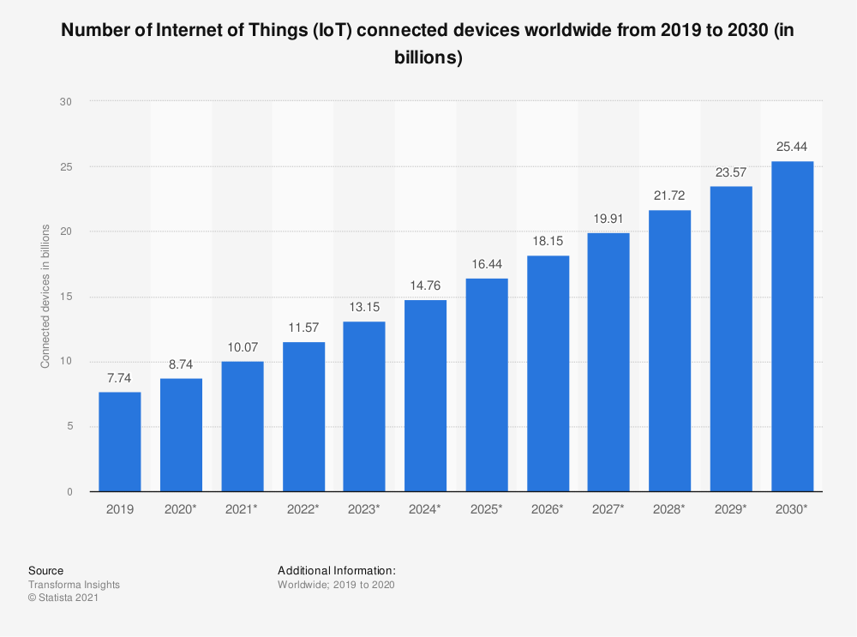

**1.2 OBJECTIVE OF THE PROJECT**

The need for electronically controlled water level in agricultural fields, even in the absence of human beings, to ensure water conservation, even supply of water based on soil moisture, suitable crops grown in that soil according to the availability of moisture content which increases the amount of harvest is indeed. We therefore intend to provide a solution by developing a prototype that has the capability of measuring moisture content, displaying suitable crops, monitoring water level in the soil by sending a notification to the farmer when the moisture has reached the required level.

The project involves the use of soil moisture sensor, LCD display, motor (water pump), android application (blynk connected with Arduino IDE). The moisture sensor measures the water content and displays the suitable crops that can be grown and processes the signal to ESP8266 which triggers the notification to the application to control water flow. With this system we can display some suitable crops and can automatically control the level of pumping in an agricultural field.

**Existing System**

The existing project assists farmers by getting live data (Temperature, humidity, soil moisture, UV index, IR) from the farmland to take necessary steps to enable them to do smart farming by also increasing their crop yields and saving resources (water, fertilizers). The product proposed uses ESP32s Node MCU, breadboard, DHT11 Temperature and Humidity Sensor, Soil Moisture Sensor, SI1145 Digital UV Index / IR / Visible Light Sensor, Jumper wires, LEDs and live data feed can be monitored on serial monitor and Blynk mobile. This will allow farmers to manage their crop with new age in farming.

The automatic pump control and displaying the moisture content as serial output or on lcd besides controlling it through a blynk application which triggers when an event occurs has already existed.

**Drawback of Existing System**

In the existing system the crops that are suitable for the soil and use many sensors are more efficient but this takes more space and also disturbs the fields space when implemented in a real time. This may decrease the effectiveness of the soil. Some existing systems use Arduino UNO in addition to ESP8266 NODE MCU but it can be curtailed by using only ESP8266 NODE MCU as it can only control the sensors and function as a micro controller unit. In addition, it is also used for connecting the sensors to the WiFi.

**Proposed System**

The Internet of Things (IoT) is the present and future of every field impacting everyone’s life by making everything intelligent. It is a network of different devices which make a self-configuring network. The new developments of Smart Farming with use of IoT, by day turning the face of conventional agriculture methods by not only making it optimal but also making it cost efficient for farmers and reducing crop wastage. The aim is to propose a technology which can generate messages on different platforms to notify farmers.

The product will assist farmers by getting live data (soil moisture) from the farmland to take necessary steps to enable them to do smart farming by also increasing their crop yields and saving resources (water, fertilizers). The product proposed in this project uses ESP8266 Node MCU, breadboard, Resistive Soil Moisture Sensor, Jumper wires and live data feed can be monitored on serial monitor and Blynk mobile. This will allow farmers to manage their crop with new age in farming.

 In this project we also try to display the names of crops better suitable before irrigation on serial monitor as output and during the irrigation a notification will be sent to control the pump through on or off button based on soil moisture. All this happens due to the wi-fi module and an android application linked to it. Therefore, the proposed project is an integration of the two possible ways of smart agriculture like displaying suitable crops and sending a notification for pump control to monitor remotely.

**1.3 ORGANIZATION OF THE REPORT**

The report includes the stepwise implementation of the working prototype and it describes the overview of how effectively the project can be implemented and allows the viewer of the report to get an overview of the project. The following is an overview of each chapter that is included in this documentation

* Chapter two includes the system Specifications where we can get clarity on the hardware and software specifications.
* Chapter three includes the design and implementation of the project including the hardware connections and software set up. It also includes the source code that can be implemented for the desired output.
* In chapter 3 we also include the output screens which would make readers easy to understand and are free from ambiguity.
* Chapter 4 includes the conclusion part where we conclude how the prototype works in whole such that a normal reader can also understand the significance of the prototype and why it is to be used.
* At last, the references are placed from where we had brought the information and idea on developing the project.

**2.SYSTEM SPECIFICATIONS**

**2.SYSTEM SPECIFICATIONS**

**2.1 SOFTWARE SPECIFICATIONS**

The software specifications that we used for the implementation of this project are as follows:

* Operating system                     : Windows 10
* Coding Language                    : C/C++
* Development environment      : Arduino
* Dataset                                    : Retrieved from acurite.com website
* IDE                                          : Arduino IDE

**2.2 HARDWARE SPECIFICATIONS**

The hardware specifications used for the implementation of this project are as follows:

* ESP8266 NODE MCU
* One way Relay Module
* Resistive soil moisture sensor
* A motor pump
* A 5V battery
* Jumper Wires
* Breadboard
* A water pipe

**3. DESIGN & IMPLEMENTATION**

**3.DESIGN & IMPLEMENTATION**

**3.1 INTRODUCTION**

In order to design this project we use the following hardware components:

1. Soil Moisture Sensor

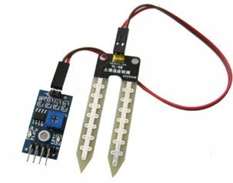

Fig 3.1.1: soil moisture sensor

Soil moisture sensor is a sensor which senses the moisture content of the soil. The sensor has both the analog and the digital output. The digital output is fixed and the analog output threshold can be varied. It works on the principle of open and short circuit. The output is high or low indicated by the LED. When the soil is dry, the current will not pass through it and so it will act as an open circuit. Hence the output is said to be maximum. When the soil is wet, the current will pass from one terminal to the other and the circuit is said to be short and the output will be zero. The sensor is platinum coated to make the efficiency high. The range of sensing is also high. It is anti-rust and so the sensor has a long life which will afford the farmer at a minimum cost. A moisture sensor is a lm393 comparator based having 4 pins Vcc, Ground, digital output, analog output (which is used here). The working principle of this sensor is very simple the analog volume changes according to the conductivity of that lead that means moisture. When moisture increases the conductivity also increases.

1. ESP8266 Node MCU

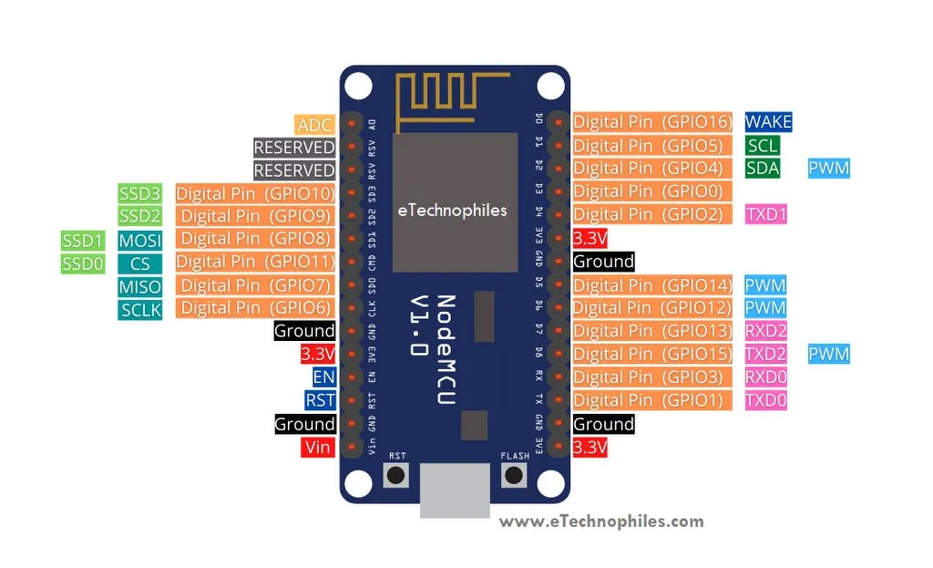

Fig 3. 1. 2: ESP8266 NODE MCU

Node MCU esp8266 wifi module is an open-source, low-cost, low power MCU development board. It has 17 GPIO pins (11 are Digital I/O pins), out of which one pin is an Analog pin, 4 pins support PWM, 2 pairs are for UART (UART0 and UART1), and supports 1x SPI and 1 x I2C protocol. Node MCU ESP8266 has 128kb of RAM, 4 MB of Flash memory, and a maximum clock speed of 160MHz (80-160). The operating current is 80mA (average). The ESP8266 integrates 802.11b/g/n HT40 Wi-Fi transceiver chip for Wi-Fi connectivity and gives it the additional advantage of creating its own network thus allowing other devices to connect directly to it. When ESP8266 was released, its open-source firmware was called Node MCU by the developers. But now the term Node MCU usually refers to the ESP8266 Wi-Fi module.

The Node MCU wi-fi module comprises of ESP12E chip (the brain of the module), GPIO pins for easy interfacing, 3.3 Volt Voltage regulator, onboard LED, USB to serial converter IC, USB port, and more. ESP8266-12E Wi-fi Chip with Antenna. This esp8266-12E or simply esp-12E chip is a member of the ESP-xx series. There are 15 modules ranging from esp01 to esp15. These are mostly used for IoT applications due to their small form factor and low price.

**Processor:**

The latest ESP12E board integrates a [**Tensilica LX106 32-bit RISC processor**](https://5.imimg.com/data5/BT/EA/MY-49702596/iot-datalogger.pdf), which achieves extra-low power consumption and reaches a maximum clock speed of 160 MHz. Uploading a program in ESP-12E using the micro USB cable is difficult as it requires a separate 3.3 voltage regulator, reset button, some resistors, and a USB to TTL converter IC. But the development board NodeMCU ESP8266 module has everything mentioned above, thus it is easy to program it from your laptop/PC. NodeMCU ESP8266 has an Esp12e chip, a USB port to upload programs, and for power supply. It also has a reset and boot button.

### **USB to TTL/Serial Converter:**

In order to program the board using a USB cable, the USB to TTL/UART converter IC is needed. NodeMCU ESP8266 has CP2102 USB to UART bridge controller IC (in SMD QFN-28 package). Some old ESP8266 boards use CH340G USB to TTL converter IC (in SMD SOP-16 package).

**Flash button:**

The boot or flash button is used while uploading the program. If you hold it down and press the EN/RST, the ESP32 will restart in flashing/uploading mode.

### **Power Pins**

**Vin:** This pin can be used to power the esp8266 board. Up to 5V can be supplied to it. The Vin pin can be used to directly supply the Node MCU esp8266 and its peripherals if you have a regulated 5V voltage source. This 5 volt is then converted to 3.3 volts using a voltage regulator as the esp12e chip requires 3.3V to operate. The Lolin ESP8266 module has one extra pin called **VU**. If the module is powered from a USB(5V), you can get 5V from the **VU** pin to power the external devices.

**3.3 V:** The board has three 3.3V pins. While the 3.3V pin is the output of a voltage regulator (CP2102), it can be used to power up the external components.

**GND:** There are a total of 4 such pins.

All the GPIO pins of the ESP8266 are 3.3 V compatible(I/O) and are not 5V tolerant. Supplying 5 volts or more directly to any of the pins may damage the board.

## NodeMCU ESP8266 Wifi Module Specifications

Let’s have a look at the specifications of NodeMCU.

|  |  |
| --- | --- |
| Microcontroller | ESP8266 32-bit |
| NodeMCU Model | Amica (Official) |
| Clock Speed | 80-160 MHz |
| USB to Serial | CP2102 |
| USB Connector | Micro USB |
| Operating Voltage | 3.3V |
| Input Voltage | 4.5V-10V |
| Flash Memory/SRAM | 4MB / 128 KB |
| GPIO Pins | 17 |
| Digital I/O Pins | 11 |
| Analog In Pins | 1 |
| PWM Pins | 4 |
| ADC Range | 0-3.3V |
| UART/SPI/I2C | 2 / 1 / 1 |
| WiFi Built-in | 802 11 b/g/n |
| Temperature Range | -40C – 125C |

As shown in the above image, there are a total of 17 GPIO (General Purpose Input Output) pins. Out of which only 11 pins are best to use. These 11 pins are mentioned in the table given below. We can use those pins as an input or output.

|  |  |  |  |
| --- | --- | --- | --- |
| Pin Name | GPIO | Input | Output |
| D0 | 16 | pull-up | pull-up |
| D1 | 5 | OK | OK |
| D2 | 4 | OK | OK |
| D3 | 0 | pull-up | OK |
| D4 | 2 | pull-up | OK |
| D5 | 14 | OK | OK |
| D6 | 12 | OK | OK |
| D7 | 13 | OK | OK |
| D8 | 15 | pull-down | OK |
| RX | 3 | pull-up | NO |
| TX | 1 | NO | pull-up |
| A0 | ADC0 | Analog | NO |

### **ADC (Analog to digital) channel**

ESP8266 has an inbuilt 10-bit ADC or analog to digital converter with only one ADC channel. In other words, the board has only one analog pin to read the analog voltage values from external devices like sensors and potentiometers.

This analog pin is marked as **A0** on the board as given in the pinout diagram above.

### UART (Universal Asynchronous Receiver-Transmitter) Pins:

The esp8266 board has 2 UART interfaces– RX0 and TX0 are UART0, RX2 and TX2 are UART1. The UART1 is used for uploading the firmware or program.

#### UART0 Pins

* U0 TXD (GPIO1)
* U0 RXD (GPIO3)

#### UART1 Pins

* U1 TXD (GPIO15)
* U1 RXD (GPIO13)

### **SPI Pins**

Unlike the three UART interfaces, the Esp8266 NodeMCU has only one set of SPI pins. The SPI protocol requires 4 pins: MOSI, MISO, SCLK, and CS.

* GPIO 7: MISO
* GPIO 8: MISO
* GPIO 6: SCLK
* GPIO 11: CS

### **I2C Pins**

The ESP8266 does not support any hardware I2C protocol, but it is possible to implement it in the programming part. So, you may use any GPIO pins as I2C as long as you are aware of the I2C programming. Only two pins are required for I2C: SDA and SCLK.

Usually, the following GPIOs are used as I2C pins:

* GPIO 4: SDA
* GPIO 5: SCL

### **PWM Pins**

The board comes with 4 PWM-enabled pins. The PWM output can be used for driving digital motors and LEDs. PWM pins on the ESP8266 board are **GPIO 4, GPIO 12, GPIO 14, and GPIO 15**. OR digital pins **D2, D5, D6, and D8**.

### **EN or Enable Pin**

It enables the esp8266 chip i.e, ESP12E when pulled high.

### **RST or Reset Pin**

This pin resets the board when pulled low. It works like the onboard reset button.

### **Wake Pin(D0)**

This pin is used to wake up the esp8266 chip from a deep sleep.

EN, RST, and Wake pin are called the control pins of the ESP8266 board.

1. Single Channel Relay Module

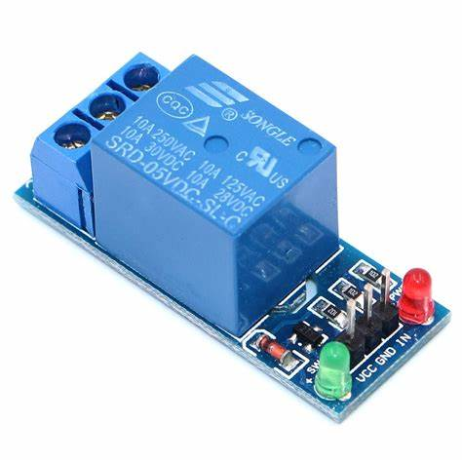

Fig 3.1.3 Single channel relay module

## We are going to use one channel relay module. However there are other modules with two, four and eight channels. You can choose the one that best suits your needs. This module is designed for switching only a single high powered device from your micro controller. It has a relay rated up to 10A per channel at 250VAC or 30VDC.

### **LEDs**

There are two LEDs on the relay module indicating the position of the relay. The Power LED will light up when the module is powered. The Status LED will light up when the relay is activated.

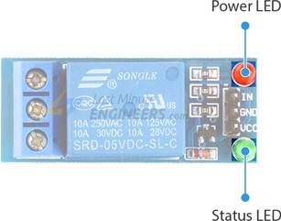

### **Output Terminal Block**

We have three channels of the relay broken out to blue screw pin terminals. The channels are labeled for their function: common (COM), normally closed (NC), and normally open (NO). The names explain the state of the channel with relation to the switch at rest.

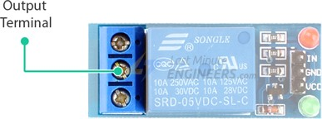

**COM (Common)**

This is the pin you should connect to the signal (mains electricity in our case) you are planning to switch.

**NC (Normally Closed)**

A normally closed configuration is used when you want to turn off the relay by default. In this configuration the relay is always closed and remains closed until you send a signal from the Arduino to the relay module to open the circuit.

**NO** **(Normally Open)**

A normally open configuration works the other way in which the relay is always open until you send a signal from the Arduino to the relay module to close the circuit.

### **Control Pins**

On the other side of the module, there are three pins – a Ground pin and a VCC pin to power the module and an input pin IN to control the relay.

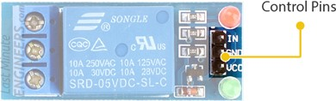

The input pin is active low, meaning the relay will be activated when you pull the pin LOW and it will become inactive when you pull the pin HIGH.

## One Channel Relay Module Pinout

Let’s have a look at the pinout of one channel relay module.

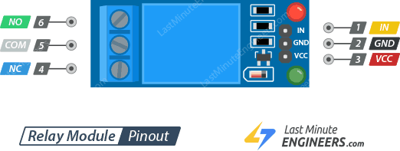

### **Control Pins:**

IN pin is used to control the relay. It is an active low pin, meaning the relay will be activated when you pull the pin LOW and it will become inactive when you pull the pin HIGH.

GND is the ground connection.

VCC pin supplies power to the module.

### **Output Terminal:**

COM pin is connected to the signal you are planning to switch.

NC pin is connected to the COM pin by default, unless you send a signal from the Arduino to the relay module to break the connection.

NO pin is open by default, unless you send a signal from the micro controller to the relay module to make the connection.

1. Bread Board

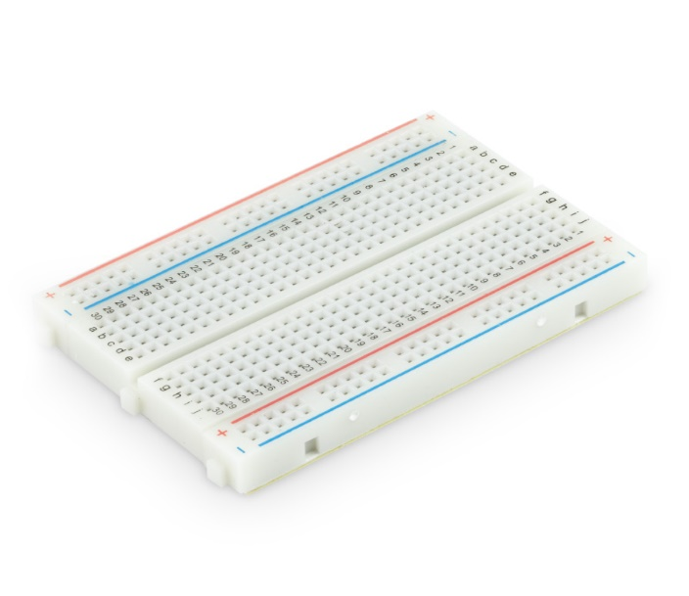

Fig 3.1.4 Bread Board

A breadboard is an electronic tool which can be used to test electrical circuits. Instead of using [soldering](https://simple.wikipedia.org/wiki/Soldering) to connect wires and components together (like on a [perfboard](https://simple.wikipedia.org/w/index.php?title=Perfboard&action=edit&redlink=1) or [printed circuit board](https://simple.wikipedia.org/wiki/Printed_circuit_board)), they can be stuck into the holes of the breadboard. It has metal strips inside that will connect them, and it lets them be removed easily or moved around when testing a circuit.

The rows and columns of holes on a breadboard are usually labelled with numbers and letters. Everything in a row with the same number will be connected, except if the breadboard has a strip down the center. In that case, the metal is split and the row has two separate connections (one on each side). The center strip is also useful when connecting [integrated circuit](https://simple.wikipedia.org/wiki/Integrated_circuit)s, because they can be pushed in over the top of it and have legs connecting to both sides without overlapping the connections. 22 or 24 gauge wire usually work best to plug into the holes in a breadboard.

Bread Board makes our work of connecting two hardware components easier. The terminals of two components are sorted to each other by inserting into the respective columns and rows holes. This way of connecting also ensures less damage to the copper wires inside the connecting wires. In this project bread board is used to connect the soil moisture sensor and ESP8266 NODE MCU.

1. Jumper Wires

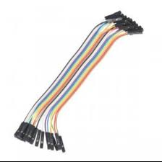

Fig 3.1.5 Jumper wires

A jump wire (also known as jumper, jumper wire, jumper cable, DuPont wire or cable) is an [electrical wire](https://en.wikipedia.org/wiki/Electrical_wire), or group of them in a cable, with a connector or pin at each end (or sometimes without them – simply "tinned"), which is normally used to interconnect the components of a [breadboard](https://en.wikipedia.org/wiki/Breadboard) or other prototype or test circuit, internally or with other equipment or components, without soldering. Individual jump wires are fitted by inserting their "end connectors" into the slots provided in a breadboard, the [header connector](https://en.wikipedia.org/wiki/Pin_header#Header_connector) of a circuit board, or a piece of test equipment.

1. DC MOTOR PUMP

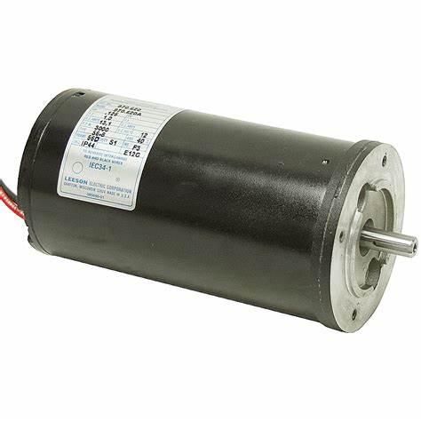

Fig 3.1.6 DC motor pump

DC powered pumps use direct current from motor, battery, or solar power to move fluid in a variety of ways. Motorized pumps typically operate on 6, 12, 24, or 32 volts of DC power. Solar-powered DC pumps use photovoltaic (PV) panels with solar cells that produce direct current when exposed to sunlight.

The connections of the specified hardware components are as specified below.

Required Components:

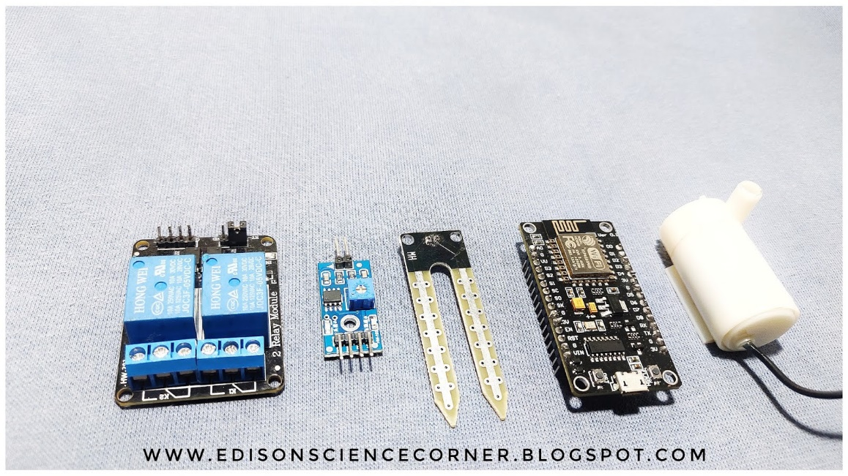

Fig 3.1.7 Required Components

The connections between soil moisture sensor, esp8266 NODE MCU and single channel relay module:

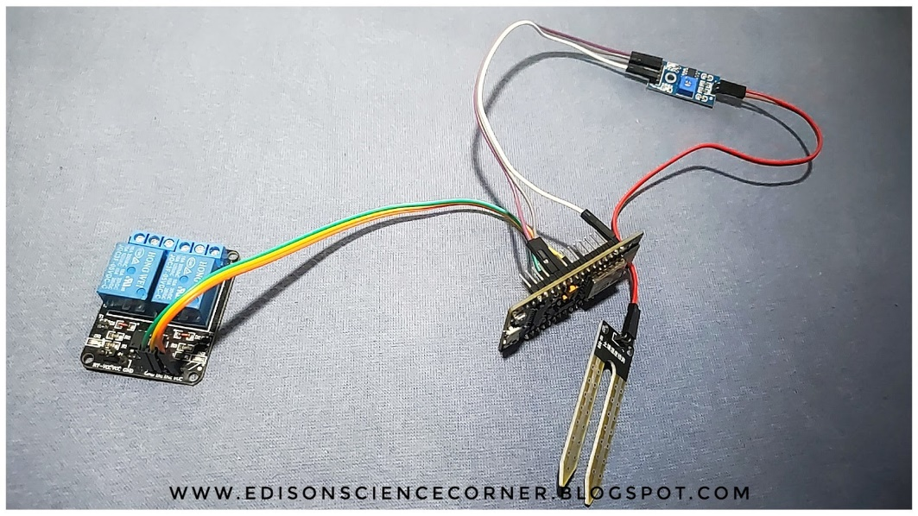

Fig 3.1.8 Connecting moisture sensor, relay module, esp8266

The connections between dc motor pump, single channel relay module and esp8266 wifi module.

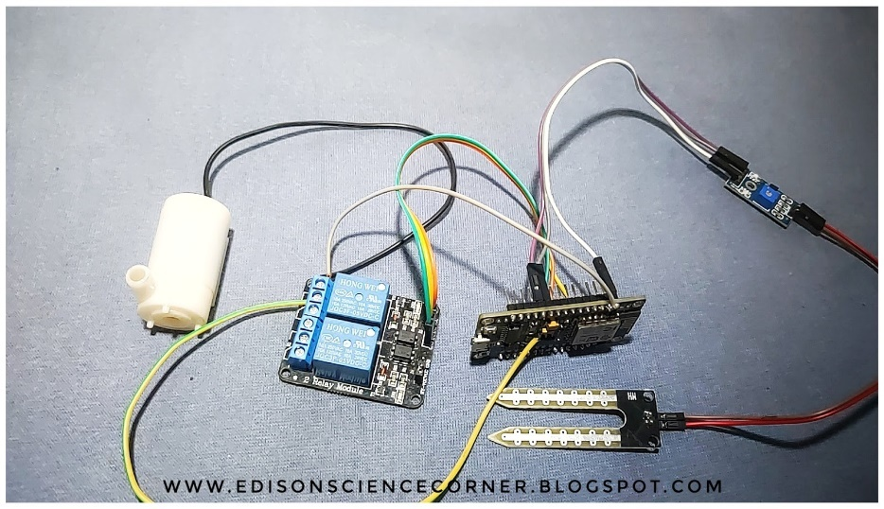

Fig 3.1.9 Connecting motor to the set up

The entire circuit diagram depicting the entire connections between motor, single channel relay module, soil moisture sensor and esp8266 along with battery is shown below. The connections are made as follows.

First connect the moisture sensor to Node MCU respectively:

GND-GND

Vcc-3V

Analog output-Analog input

Then connect Relay module to Node MCU respectively:

Vcc-3V

GND-GND

INP pin- digital pin 1

Later connect pump to relay module and external 5V battery that is also connected to relay module.

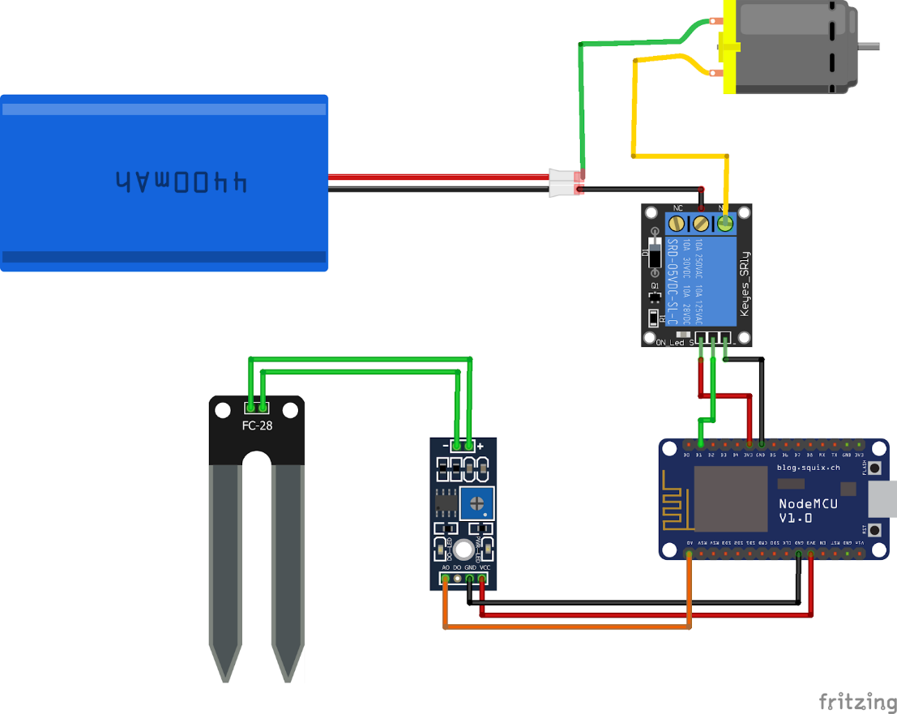

Fig 3.1.10 Circuit diagram with all the connections

**Setting up a Blynk application**

Blynk is an application that can run over Android and IOSdevices to control any IoT devices and Appliances using our smartphones. First of all, a Graphical User Interface (GUI) needs to be created to control the RGB LED matrix. The application will send all the selected parameters from the GUI to the Blynk Cloud. In the receiver section, we have Arduino connected to the PC via a serial communication cable. Hence, PC requests data from the Blynk cloud, and these data are sent to Arduino for necessary processing. So, let’s get started with the Blynk application setup.

Blynk app- allows to you create amazing interfaces for controlling and monitoring your projects using various widgets we provide. Before the setup, [download the Blynk Application](https://play.google.com/store/apps/details?id=cc.blynk) from the Google Play store (IOS users can download from App Store). After installation, Sign-up using your email id and Password.

**Creating a New Project:**

After successful installation, open the application, and there we will get a screen with an option “New Project”. Click on it and it will pop up a new screen, where we need to set the parameters like Project name, Board, and connection type. In our project, select the device as “ESP8266**”** and connection type as “Wi-Fi” and click on “Create**”**. After the successful creation of the Project, we will get an Authenticate ID in our registered mail. Save the Authenticate ID for future reference.

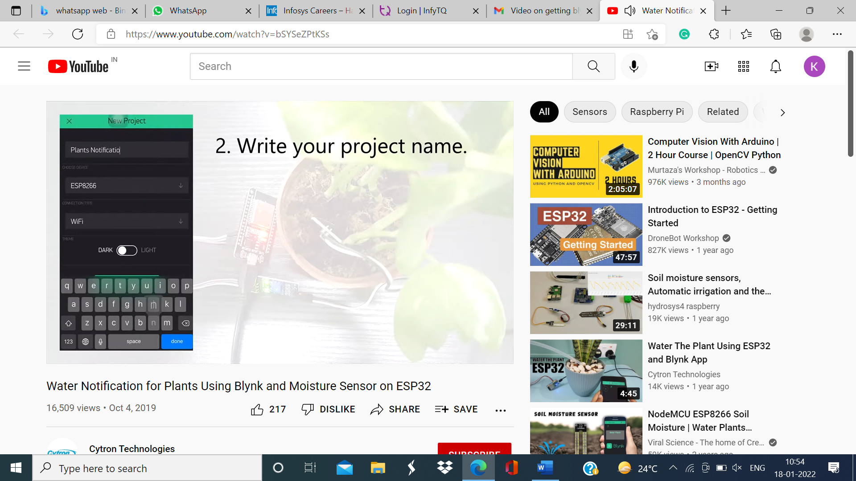

Fig 3.1.11 Creating a new project on blynk

Now add widgets to the application interface and add the guage button and name it as a moisture. This guage button is used to represent the moisture through the sensor and select the pin as V5 then arrange the guage button.

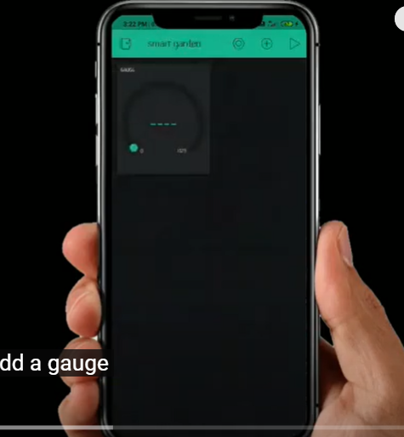

Fig 3.1.12 Adding a guage widget

Next add a button and select d1because we connected the relay module to d1 and name it as pump. To get a notification from up we need to add the notification button.

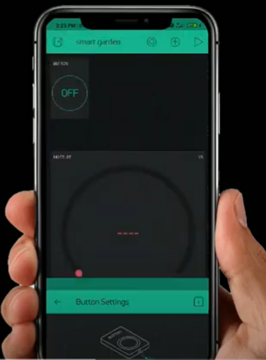 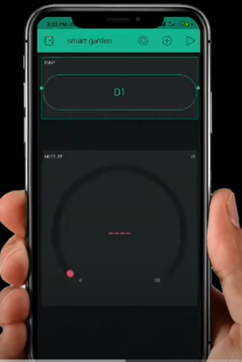 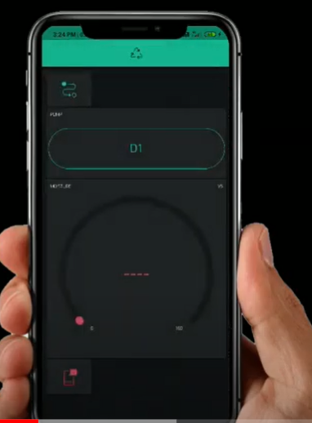

Fig 3.1.13 Adding and setting up the widgets like button, notification

Now add button or event so after that click on add a new event when moisture b5 is lower than 10 then turn on pin d1 and also send notification there we added a pump activated as notification and also add one more event when moisture v5 is higher than 15 10 of d1 that means when moisture goes below 10 the pump will automatically turn on and send notification and also whenever the moisture goes higher than 15 then motor will turn off this circuit.

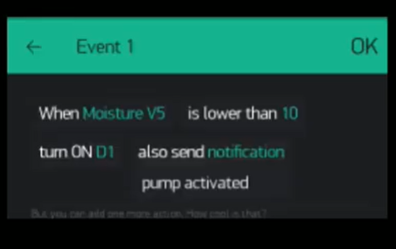 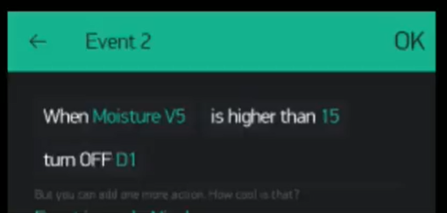

Fig 3.1.14 Creating events for getting a notification and automated pump

The interaction of Blynk with server and reading from sensors can be noted as shown below through the esp8266 wifi module and soil moisture sensor (through which input is read).

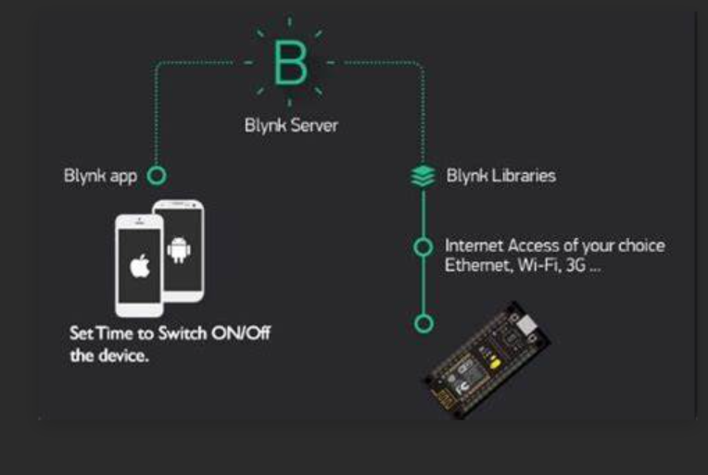

Fig 3.1.15 Blynk server and its working

In order to have the accurate implementation on knowing the kind of crops grown and to monitor the pump according to the respective moisture content according to the crops growing there. We can have the dataset for more accuracy. Here is the sample dataset taken from accurite.com.

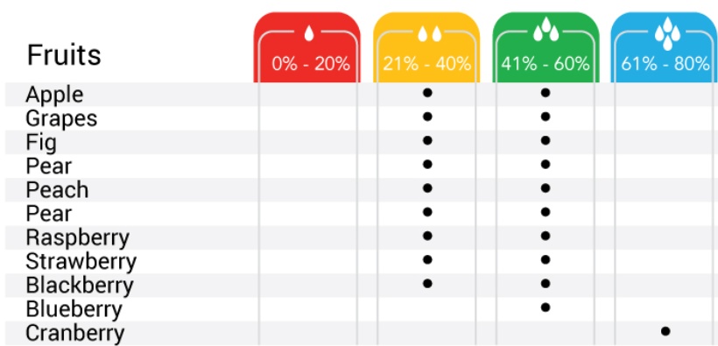

Fig 3.1.16 Dataset

**3.2 Source Code**

The project involves two parts of displaying names of crops and second part is all about triggering a notification based on threshold set based on the crops grown there. Here there is a flowchart of how the prototype is implemented and executed.

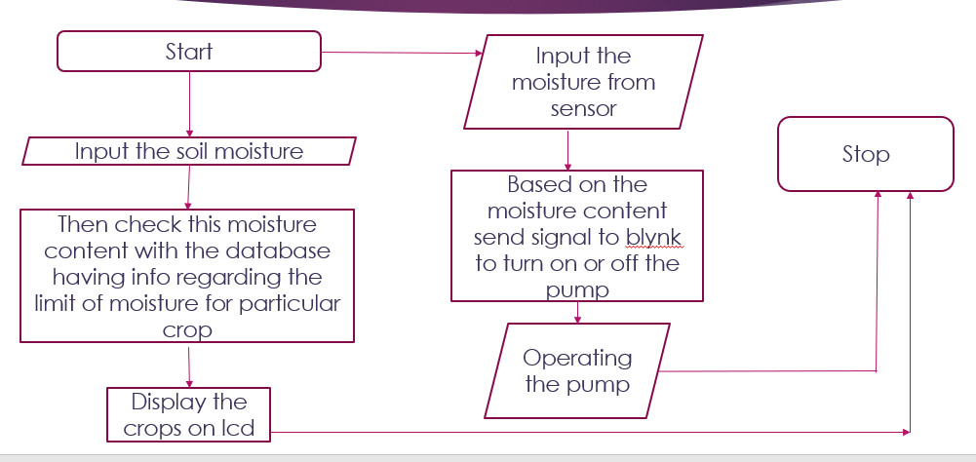

Fig 3.2.1 Overall flowchart displaying what kind of crops can be displayed and pump monitoring

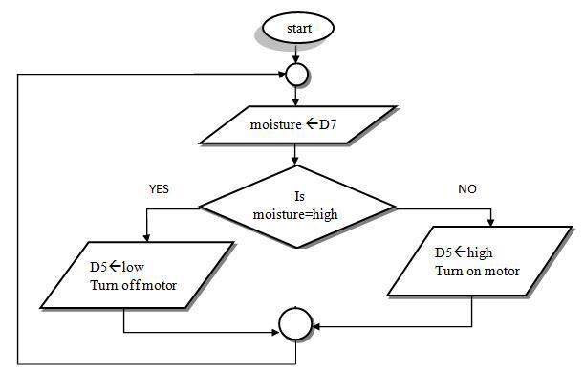

Fig 3.2.2 Flowchart for the pump control based on the moisture read on pin connected

**The source code for monitoring pump is**

#define BLYNK_PRINT Serial

#include<ESP8266WiFi.h>

#include<BlynkSimpleEsp8266.h>

char auth[]="RMZ8Y81D1LqEfS8CKqSyQWWQS1ii7IZi";

char ssid[]="Redmi Y3";

char pass[]="123456789";

int moisture;

int data1;

void setup() {

// put your setup code here, to run once

Serial.begin(9600);

pinMode(A0,INPUT);

Blynk.begin(auth,ssid,pass);

}

void loop()

{

Blynk.run();

moisture=analogRead(0);

// moisture=DigitalRead(0)

delay(100);

data1=map(moisture,500,1023,100,0);

Serial.println();

Serial.print("moisture:");

//serial.println();

Serial.println(data1);

if(data1==1){Serial.println("Nocrop");}

else{Serial.println("Chilli");}

Blynk.virtualWrite(V5,data1);

//if(da>80){

//Blynk.notify("Water reached level");}

// put your main code here, to run repeatedly

}

|  |
| --- |
|  |
|  |
|  |
|  |
|  |
|  |
|  |
|  |
|  |
|  |
|  |
|  |
|  |
|  |
|  |
|  |
|  |
|  |
|  |
|  |
|  |
|  |
|  |
|  |
|  |
|  |
|  |
|  |
|  |
|  |
|  |
|  |
|  |
|  |
|  |
|  |
|  |
|  |
|  |
|  |
|  |
|  |
|  |
|  |
|  |
|  |
|  |
|  |
|  |
|  |
|  |
|  |
|  |  |

The code is uploaded to our esp module. Initially we included the blynk library, the bsp library, then include the Blynk token and wifi credentials. In setup() we have declared the pins then we used Blynk Virtual Write() function to send the data to the server. That’s all about this programming.

The Pseudo Code for displaying the crops suitable according to the moisture content measured.

if(moisture>=0&&moisture<=20)

{

Serial.print("Rugosa,Cactus");

}

else if(moisture>=21&&moisture<=40)

{

Serial.print("Apple,Grapes,Lily");

}

else if(moisture>=41&&moisture<=60)

{

Serial.print("Pear,Peach,Daliya");

}

else

Serial.print("Cranberry,Paddy");

**3.2.1 OUTPUT SCREENS**

Here we have three glasses of soil with different moisture contents.

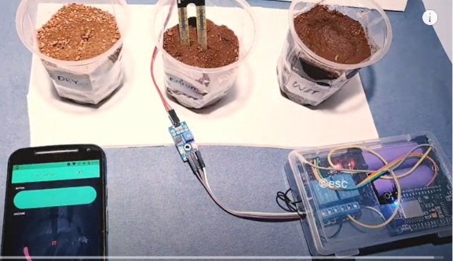 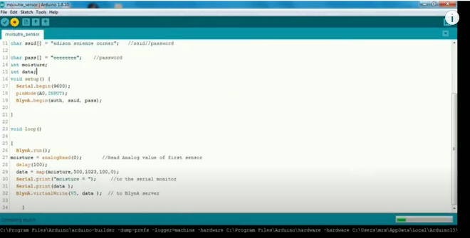

Fig 3.2.1.1 Change in guage metrics Fig 3.2.1.2 Uploading of code

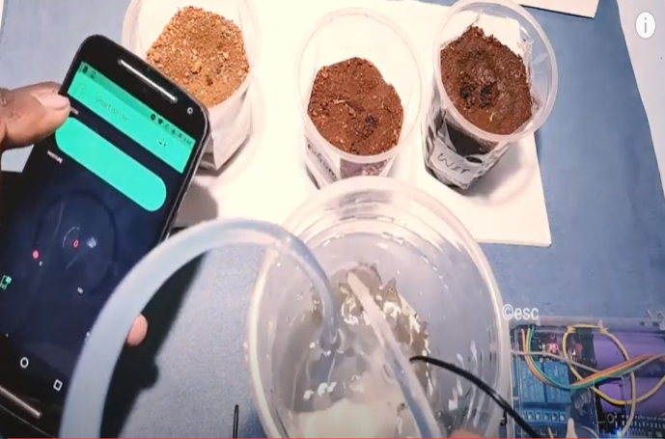 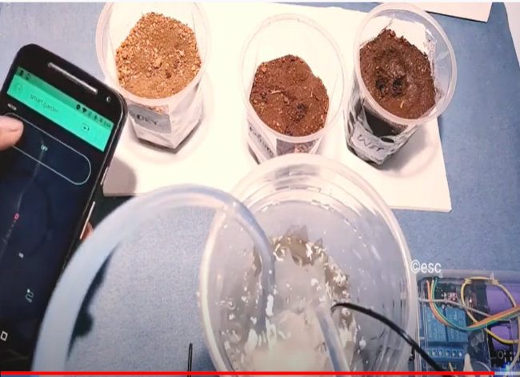

Fig 3.2.1.3 Controlling pump through button actions

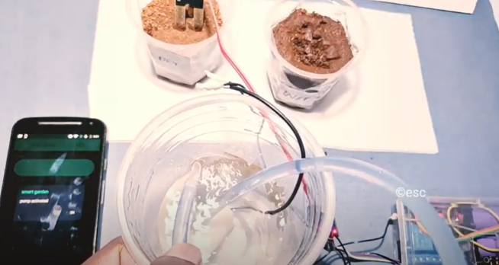 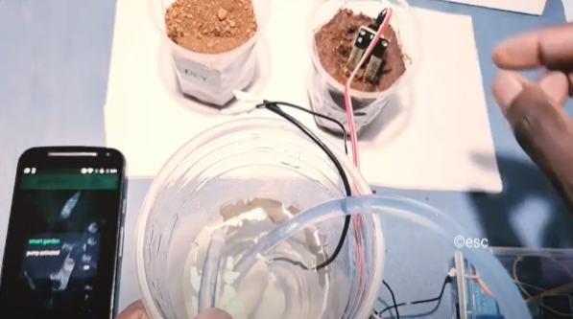

Fig 3.2.1.4 Triggering of notification when moisture is not up to the mark or reached the level

**3.3 TESTING**

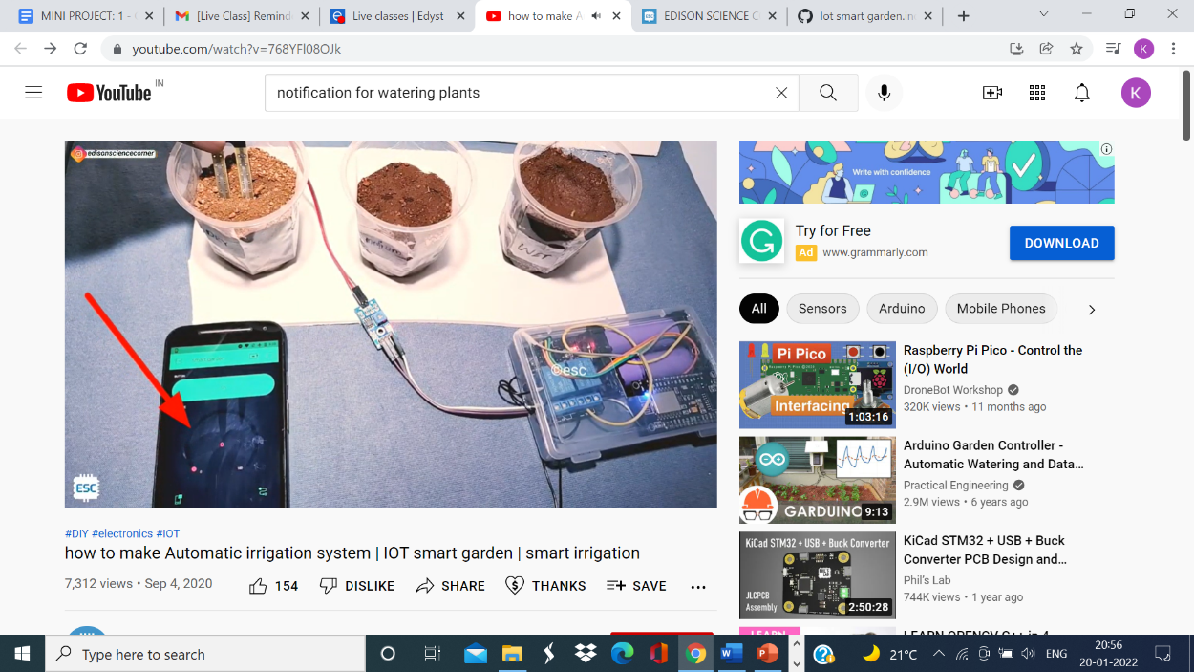 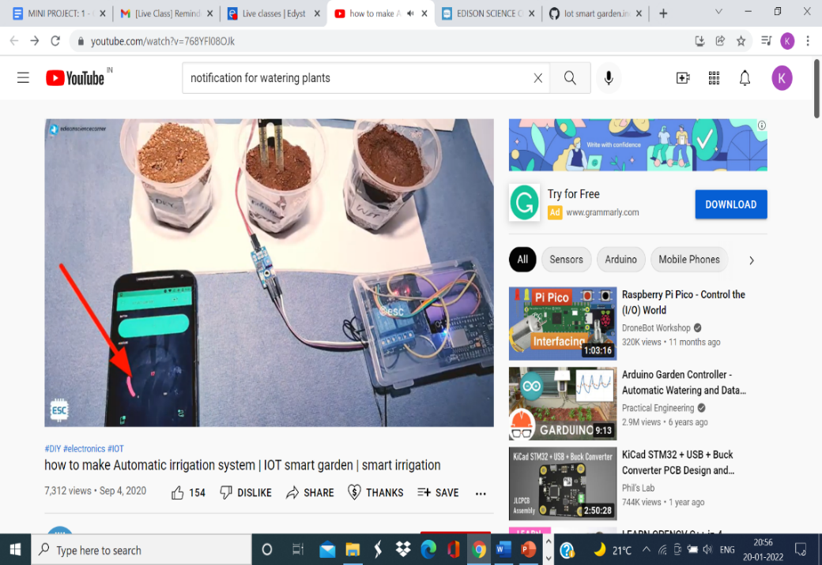

(i) (ii) 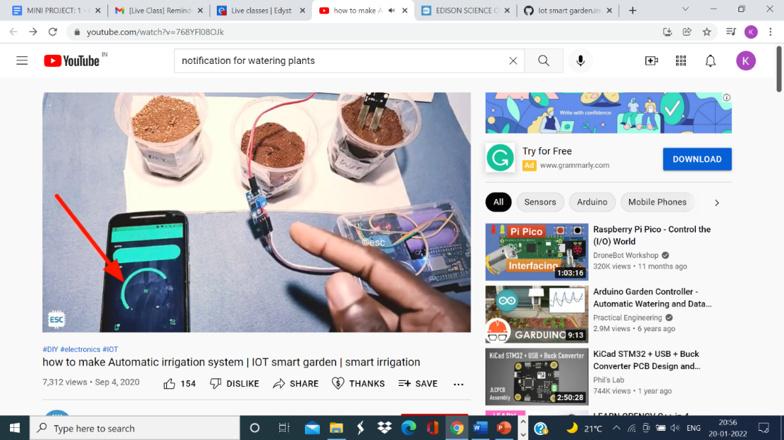

(iii)

(i): Gauge measuring least when placed in dry soil

(ii): Gauge measuring some percentage when placed in medium soil

(iii): Gauge measuring large percentage when placed in wet soil

 

When the probe is placed in dry soil the motor is working, when the probe is placed in wet soil the pump gets deactivated. Thus, we get the desired output.

**CONCLUSION**

**CONCLUSION**

Currently, farmers control irrigation method manually and irrigate their area at a systematic period. These mechanisms deplete highly amount of water and the outcome is water loss. While dry areas have less rainfall and irrigation is challenging, it is indeed for the farmers to know the kind of crops grown according to the availability of water. So, a system to monitor the moisture levels in the soil was designed that provides an opportunity to study the existing systems, along with their features. The proposed system can be used to turn on/off the water sprinkler according to the soil moisture levels there by automating the process of irrigation, which is one of the most time consuming activities in farming, with an ESP8266 Wi-Fi based communication system for the ease of maintenance, price and operation (can be operated from anywhere in the fraction of time). Therefore, it can be concluded that there can be a considerable development in farming with the use of IOT automation.

**REFERENCES**

**REFERENCES**

[1] S. Darshna1, T.Sangavi, Sheena Mohan, A.Soundharya,Sukanya,“Smart Irrigation System”, IOSR-JECE, May – Jun 2015.

[2] G. Parameswaran and K.Sivaprasath,“Arduino Based Smart Drip Irrigation System Using Internet of Things”, IJESC Volume 6 Issue No. 5.

[3] P. Singh and S. Saikia, “Arduino-based smart irrigation usingwater flow sensor, soil moisture sensor, temperature sensor andESP8266 WiFi module”, 2016 IEEE Region 10 HumanitarianTechnology Conference (R10-HTC), Agra, India, 2016, pp. 1-4.

[4] Ravi Kishore Kodali and Borade Samar Sarjerao, “A Low Cost Smart Irrigation System Using MQTT Protocol”, IEEE Region 10 Symposium (TENSYMP), Cochin, India, 2017, pp. 1-5.

[5] PriyankaPadalalu, SonalMahajan, KartikeeDabir, SushmitaMitkarandDeepaliJavale, “Smart Water Dripping System for Agriculture/Farming”,2nd International Conference for Convergence in Technology (I2C T), Mumbai, India, 2017, pp. 659 – 662.

[6] K. Lekjaroen, R. Ponganantayotin, A. Charoenrat, S. Funilkul, U. Supasitthimethee and T. Triyason, “IoT Planting: Watering system using mobile application for the elderly”, 2016 International Computer Science and Engineering Conference (ICSEC), Chiang Mai, Thailand, 2016, pp. 1-6.

[7] V. H. Andaluz, A. Y. Tovar, K. D. BedÃ¸sn, J. S. Ortiz and E. Pruna, “Automatic control of drip irrigation on hydroponic agriculture: Daniela tomato production”, 2016 IEEE International Conference on Automatica (ICA-ACCA), Curico, 2016, pp. 1-6.

[8] V. V. h. Ram, H. Vishal, S. Dhanalakshmi and P. M. Vidya, “Regulation of water in agriculture field using Internet Of Things”, 2015 IEEE Technological Innovation in ICT for Agriculture and Rural Development (TIAR), Chennai, 2015, pp. 112-115.

[9] J. Shenoy and Y. Pingle, “IOT in agriculture”, 2016 3rdInternational Conference on Computing for Sustainable Global Development (INDIACom), New Delhi, 2016, pp. 1456-1458.

[10] Rosley, Samad. Z, Shaari M.F., Rosley, M.A., “Feasibility studies of Arduino microcontroller usage for IPMC actuator control,” in IEEE International Conference on Control System, Computing and Engineering (ICCSCE), 2014, pp.101-106,28-30 Nov. 2014.

[11] Leo Louis, “Working Principle of Andruino and Using It as a tool for study and research”, International Journal of Control, Automation, Communication and Systems (IJCACS), Vol.1, No.2, April 2016.

[12] SaraswatiSaha; AnupamMajumdar. “Data centre temperature monitoring with ESP8266 based Wireless Sensor Network and cloud based dashboard with real time alert system” , 2017 Devices for Integrated Circuit (DevIC), 23-24 March, 2017, pp.307-310.

[13] PallaviRavindra Joshi1 and Prof. M S khan, “IOT Based Smart Power Management System Using WSN”, International Journal of Advanced Research Trends in Engineering and Technology, Vol: 04, Issue: 06, June -2017.

[14] Dr. Narayan G. Hegde, “Water Scarcity and Security in India”, BAIF Development ReseachFoundation, Pune.

[15] Karan Kansara, Vishal Zaveri, Shreyans Shah, Sandip Irrigation System with IOT: A Technical Science and Information Technologies, Vol. 6 (6) , 2015, 5331-5333

Delwadkar, and Kaushal Jani “Sensor based Automated

Review”,(IJCSIT) International Journal of Computer

India”, BAIF Development ReseachFoundation, Pune